深 圳 大 学 实 验 报 告

课程名称： Database System

实验项目名称： Data Modelling using PowerDesigner

学院： Computer Science and Software Engineering

专业： Software Engineering

指导教师： Basker George

报告人_____叶家霖____学号：2019285006_____班级：________国际班___

实验时间： 6th December, 2020

实验报告提交时间： 6th December, 2020

教务部制
实验目的与要求：(Purpose of Experiment purpose and Requirements)
* Please show all work for these problems.
Just writing down the answer will not get full credit.

Transform the following ER diagram into Relations and Create the required tables using Oracle / MySQL: (with Primary Key, Foreign Key if any, Data types, Width, Domain and Integrity Constraints )

Identify the following
- Identify the type of relationship (1:1, 1:m, m:m)

- Identify the cardinality (Min, Max)
- Primary Key

EER diagram 1):

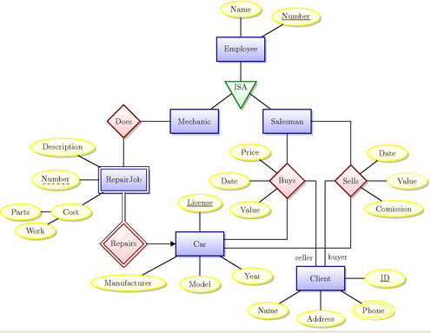
1.Identify the type of relationship (1:1, 1:m, m:m)
1:m:
Car-Repair Job
Salesman-Car
Client-Car

m:m:
Mechanic-Repair Job

2.Identify the cardinality (Min, Max)
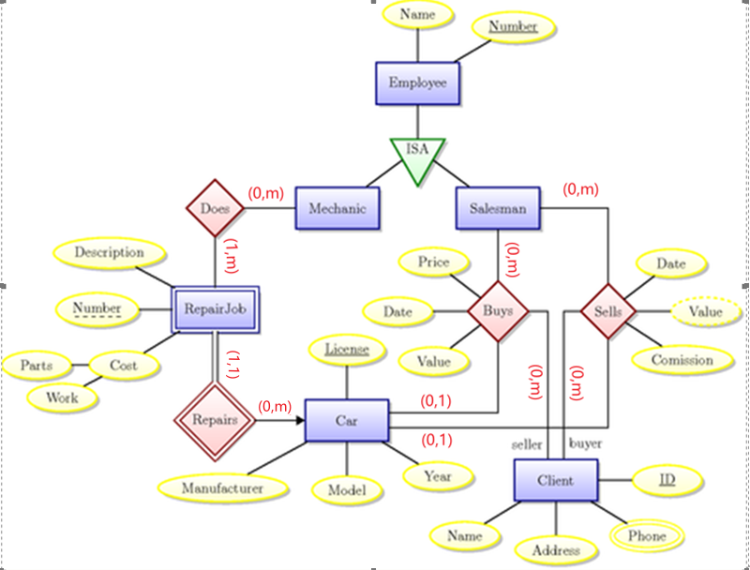

3.Primary Key
Table Emp (Number , name)
Table RepairJob (RNumber, Description)
Table RepairCost ( RNumber, Parts, Work)
Table Cars(License,Manufacturer,Model,Year)
Table Client(ID , Address, Name)
Table Client_Phone(ID , phone)

Table Dose(Number, Rnumber)
Table Repairs (Rnumber ,license)
Table ClientToSales(Number ,license, ID, Date ,Value ,Price)
Table SalesToClient(Number ,license,ID, Date, Commission)

SQL:

/*==============================================================*/
/* Table: Cars */
/*==============================================================*/
create table Cars
(
License int not null,
Manufacture text null,
Model text null,
Year dec(4) null,
constraint PK_CARS primary key clustered (License)
);

/*==============================================================*/
/* Table: Client */
/*==============================================================*/
create table Client
(
ID int not null,
Address text null,
Name varchar null,
constraint PK_CLIENT primary key clustered (ID)
);

/*==============================================================*/
/* Table: ClientToSales */
/*==============================================================*/
create table ClientToSales
(
Number int not null,
license varchar not null,
ID varchar not null,
"Date" date null,
Value float null
constraint CKC_VALUE_CLIENTTO check (Value is null or (Value >= 0)),
Price float null
constraint CKC_PRICE_CLIENTTO check (Price is null or (Price >= 0)),
constraint PK_CLIENTTOSALES primary key clustered (Number, license, ID)
);

/*==============================================================*/
/* Table: Client_Phone */
/*==============================================================*/
create table Client_Phone
(
ID varchar not null,
phone varchar not null,
constraint PK_CLIENT_PHONE primary key clustered (ID, phone)
);

/*==============================================================*/
/* Table: Dose */
/*==============================================================*/
create table Dose
(
Number int not null,
Rnumber int not null,
constraint PK_DOSE primary key clustered (Number, Rnumber)
);

/*==============================================================*/
/* Table: Emp */
/*==============================================================*/
create table Emp
(
Number int not null,
name varchar null,
constraint PK_EMP primary key clustered (Number)
);

/*==============================================================*/
/* Table: RepairCost */
/*==============================================================*/
create table RepairCost
(
RNumber int not null,
Parts text null,
"Work" text null,
constraint PK_REPAIRCOST primary key clustered (RNumber)
);

/*==============================================================*/
/* Table: RepairJob */
/*==============================================================*/
create table RepairJob
(
RNumber int not null,
Description text null,
constraint PK_REPAIRJOB primary key clustered (RNumber)
);

/*==============================================================*/
/* Table: Repairs */
/*==============================================================*/
create table Repairs
(
Rnumber int not null,
license varchar null,
constraint PK_REPAIRS primary key clustered (Rnumber)
);

/*==============================================================*/
/* Table: SalesToClient */
/*==============================================================*/
create table SalesToClient
(
Number varchar not null,
license varchar not null,
ID varchar null,
"Date" date not null
constraint CKC_DATE_SALESTOC check ("Date" >= '0'),
Commission float null,
constraint PK_SALESTOCLIENT primary key clustered (Number, license, ID)
);
alter table Repairs add constraint FK_used foreign key (license)
references Cars (license) on delete restrict on update restrict;
alter table Repairs add constraint FK_used foreign key (license)
references Cars (license) on delete restrict on update restrict;

Case Study
A relational database is to be designed for a medium sized Company dealing with developing application software. The Company delivers various products to its customers ranging from a single application program to customized software. The Company employs various experts, consultants and supporting staff. All personnel are employed on long-term basis, i.e. there are no short-term or temporary staffs.

Although the Company is somehow structured for administrative purposes (that is, it is divided into departments headed by department managers) all projects are carried out in an inter-disciplinary way. For each project has a Start date when a project team is selected, grouping employees from different departments, and a Project Manager (also an employee of the Company) is appointed who is entirely and exclusively responsible for the control of the project, quite independently of the Company’s hierarchy. The following is a brief statement of some facts and policies adopted by the Company.
Entities
- Department
- Employee （job:experts, consultants and supporting staff,Depaerment,manager）
- Skills
- Team
- Customers
- Product
- Projects(StartDate,Project manager ,)
- Spouse（配偶）
- Dependent(children of employee)

Relationships
- Employees work for different department headed by a Manager
- Employee has Spouse and Dependent (child)
- Each department manages many employees.
- Employees are divided into many teams
- Each Team manages a project
- Each Department is Headed by a Department Manager
- Each Employees belongs to one team
- A Project is headed by Project Team
- Skills are used in projects

实验过程及内容：(Methods and steps)
- Identify all entities you can think of
• Department
• Employee
• Skills
• Team
• Customers
• Order
• Product
• Projects
• Spouse（配偶）
• Dependent(children of employee)
- Identify all the attributes
Department(DeptNo,Dname,MRG)
Employee(ENO, Spouse, Dependent，age ,Job)
Spouse(name,age)
Dependent(name,age)
Skills(skills)
Team(Tname,TNo)
Projects(StartTime,Pname,PNo, MRG)
Product(ItemNo，Price,Description)
Order(OrderNum,Date,Sum)
Customers(name)
- Identify atomic, composite and derived attributes
Atomic: DeptNo,Dname,MRG,ENO,Job, Tname, TNo, OrderNum, Pname,name,age ,skills, StartTime, Description,ID ,ItemNo, PNo
Composite: Spouse, Dependent, TNo, OrderNum,name
Derived: order.Sum
Identify Primary key or Composite Primary Key
key :
Department(DeptNo,Dname,MRG)
Employee(ENO, Spouse, Dependent，age ,Job)
Spouse(name,age)
Dependent(name,age)
Skills(skills)
Team(Tname,TNo)
Projects(StartTime,Pname,PNo, MRG)
Product(ItemNo，Price,Description)
Order(OrderNum,Date,Sum)
Customers(name)

Composite Primary: ENO +name(for Spouse and Dependent )
- Identify all relationships between the entities
• Employees work for different department headed by a Manager
• Employee has Spouse and Dependent (child)
• Each department manages many employees.
• Employees are divided into many teams
• Each Team manages a project
• Each Department is Headed by a Department Manager
• Each Employees belongs to one team
• A Project is headed by Project Team
• A Project has a manager
• Skills are used in projects
• A customer contains lots of products
• A Order contains lots of products
• A product need a unique project

- Identify any attributes for relationship
None
- Identify the type of relationship (1:1, 1:m, m:m)
1:m:
Department-Employee
Team – Employee
Customer- Order
Order- Product
-

1:1:
Employee- Spouse
Employee- Dependent
Product-Project
Project-Team
m:m
Skills-Project
- Identify the cardinality (Min, Max)
Department-(1,n)—(1,1)Employee
Team (0,n)--- (0,1) Employee
Customer(1,n)---(1,1)Order
Order(1,n)- (1,1)Product

Employee(0,1)-(1,1) Spouse
Employee(0,n)-(1,1) Dependent
Product(1,1)-(1,1)Project
Project(1,1)-(1,1)Team
Skills(0,n)-(1,n)Project

Draw the Logical Data Model and Physical Data Model for Oracle DBMS using Power Designer

LDM:
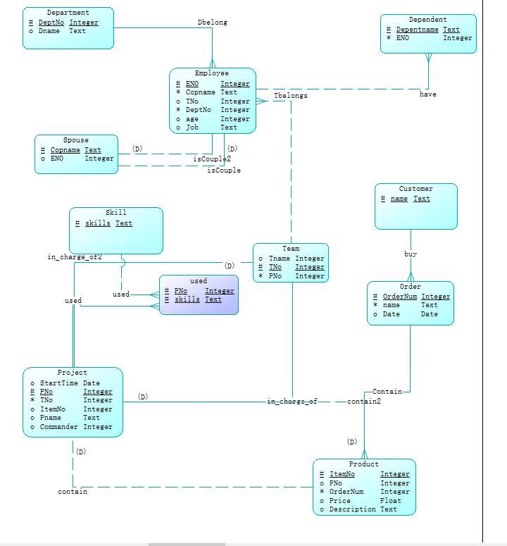
PDM:
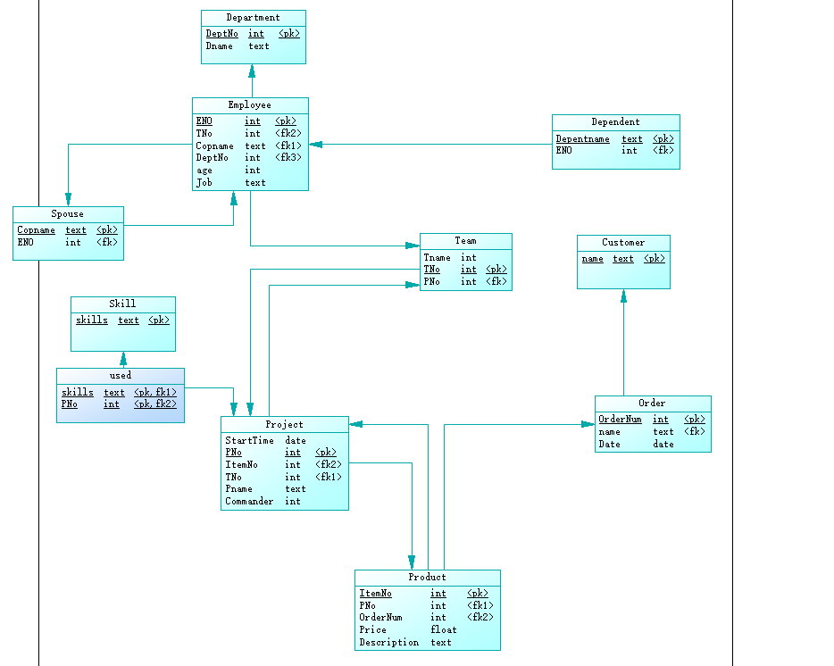
生成的SQL:
drop table if exists Customer;

drop table if exists Department;

drop table if exists Dependent;

drop table if exists Employee;

drop table if exists "Order";

drop table if exists Product;

drop table if exists Project;

drop table if exists Skill;

drop table if exists Spouse;

drop table if exists Team;

drop table if exists used;

/*==============================================================*/
/* Table: Customer */
/*==============================================================*/
create table Customer
(
Cname text not null,
primary key (Cname)
);

/*==============================================================*/
/* Table: Department */
/*==============================================================*/
create table Department
(
DeptNo int not null,
Dname text,
Commander int,
primary key (DeptNo)
);

/*==============================================================*/
/* Table: Dependent */
/*==============================================================*/
create table Dependent
(
Depentname text not null,
ENO int not null,
primary key (Depentname)
);

/*==============================================================*/
/* Table: Employee */
/*==============================================================*/
create table Employee
(
ENO int not null,
TNo int,
name2 text not null,
DeptNo int not null,
age int,
Job text,
primary key (ENO)
);

/*==============================================================*/
/* Table: "Order" */
/*==============================================================*/
create table "Order"
(
OrderNum int not null,
Cname text not null,
Date date,
primary key (OrderNum)
);

/*==============================================================*/
/* Table: Product */
/*==============================================================*/
create table Product
(
ItemNo int not null,
PNo int,
OrderNum int not null,
Price float,
Description text,
primary key (ItemNo)
);

/*==============================================================*/
/* Table: Project */
/*==============================================================*/
create table Project
(
StartTime date,
PNo int not null,
ItemNo int,
TNo int not null,
Pname text,
Commander int,
primary key (PNo)
);

/*==============================================================*/
/* Table: Skill */
/*==============================================================*/
create table Skill
(
skills text not null,
primary key (skills)
);

/*==============================================================*/
/* Table: Spouse */
/*==============================================================*/
create table Spouse
(
name2 text not null,
ENO int,
primary key (name2)
);

/*==============================================================*/
/* Table: Team */
/*==============================================================*/
create table Team
(
Tname int,
TNo int not null,
PNo int not null,
primary key (TNo)
);

/*==============================================================*/
/* Table: used */
/*==============================================================*/
create table used
(
skills text not null,
PNo int not null,
primary key (skills, PNo)
);

alter table Dependent add constraint FK_have foreign key (ENO)
references Employee (ENO) on delete restrict on update restrict;

alter table Employee add constraint FK_Dbelong foreign key (DeptNo)
references Department (DeptNo) on delete restrict on update restrict;

alter table Employee add constraint FK_Tbelongs foreign key (TNo)
references Team (TNo) on delete restrict on update restrict;

alter table Employee add constraint FK_isCouple2 foreign key (name2)
references Spouse (name2) on delete restrict on update restrict;

alter table "Order" add constraint FK_buy foreign key (Cname)
references Customer (Cname) on delete restrict on update restrict;

alter table Product add constraint FK_Relationship_9 foreign key (OrderNum)
references "Order" (OrderNum) on delete restrict on update restrict;

alter table Product add constraint FK_contain foreign key (PNo)
references Project (PNo) on delete restrict on update restrict;

alter table Project add constraint FK_contain2 foreign key (ItemNo)
references Product (ItemNo) on delete restrict on update restrict;

alter table Project add constraint FK_in_charge_of2 foreign key (TNo)
references Team (TNo) on delete restrict on update restrict;

alter table Spouse add constraint FK_isCouple foreign key (ENO)
references Employee (ENO) on delete restrict on update restrict;

alter table Team add constraint FK_in_charge_of foreign key (PNo)
references Project (PNo) on delete restrict on update restrict;

alter table used add constraint FK_used foreign key (skills)
references Skill (skills) on delete restrict on update restrict;

alter table used add constraint FK_used2 foreign key (PNo)
references Project (PNo) on delete restrict on update restrict;

深圳大学学生实验报告用纸

指导教师批阅意见：

成绩评定：

指导教师签字：Basker George
2019年12月 04 日
备注：
注：1、报告内的项目或内容设置，可根据实际情况加以调整和补充。
2、教师批改学生实验报告时间应在学生提交实验报告时间后10日内。

